Guide style of

The Factory

“*Our style is like music. It is the motor of our effort and satisfaction.*

*And it should be written for the best use of that*”

Index:

1. Logo
2. Colors
3. Words
4. Images
5. Guide Comunications
6. Legality terms

LOGO



Our logo will be use exclusively with logo function

In the event of use logo in other place with

advertising or lucrative purposes you must contact with owners.

Finally this is the best logo in the best logo in the world in the fac of oppositive you will be demand

Don't combine the the factory name or logos, or any portion of any of them, with any other logo, company name, mark, or generic terms. Don't edit, modify, distort, rotate, or re-color the logo

We have use the website : <https://www.freelogoservices.com> to make our logo.

Colors

   

#E8E051 #E7FFFD #615F56 #00021F

Words

To font’s logo will be wash black;

That is the page where you can find typography and is only this because is the best combained posible. Font :Imperator, with size 14;

Font of logo’s is Wash Black in with size 50 ; And it’s possible resizeable

<https://www.dafont.com/es/imperator.font>

Images

Image to go to cest where it Will be found the ítems you have been selected

Image as symbol of users, where you can find the user’s option, your orders,Message Centers…

The transaction or any other process has beed completed succesfully

In case the page not load well, this icon will have the will be in order of the before



Have been occured a mistake during transaction or any other process.

In case the page not load well, this icon will have the will be in order of the before 



If the user wants see the page how a computer, the page will redimension as if was a desktop



If the user wants see the page how a phone, the page will redimension as if was a phone

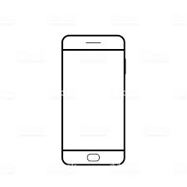

In case the page not load well, this icon will have the will be in order of the before

 This icon Will be usefull if the user wants Contac with us

In case the page not load well, this icon will have the will be in order of the before

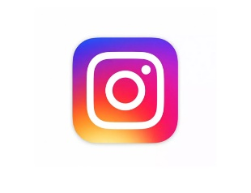If the user wants see social network this icon redirect to our instagram

Guide Comunications

All comunications will be the most plesant and succesfull as possible.

The comunications are linked with our agents that try to resolve every problems with the customers

The ways to contact with our agents are by :

* Email : [factoryinstruments@gmail.com](mailto:factoryinstruments@gmail.com)
* Facebook :
* Instagram :@factoryinstruments



Legality terms

The name and logos are trademarks of ‘The Factory’ and may only be used as described in these Guidelines. Avoid using the ‘The Factory’ for anything that would be inconsistent with the inconsistency of the page. We’ re committed to prooviding a secure and fair marketplace for our buyers. To support this commitment, we’ve put in place rules and polices that govern our expectatios of, the actions we’ll take to keep you safe, and how we’ll protect you if something goes wrong.

you'll help us maintain a safe environment for all, and be able to avoid interruptions that might come from inadvertent violations of our rules.

Some of our rules reflect local legal requirements, while others are based on our experience of how best to protect everyone using ‘The Factory’ services.